AHMED RASHID |  | www.ahmedrashid.com
ARTICLES | Nation Horrified To Learn About War In Afghanistan While Reading Up On Petraeus Sex Scandal
ARTICLES | News in Brief , November 13, 2012
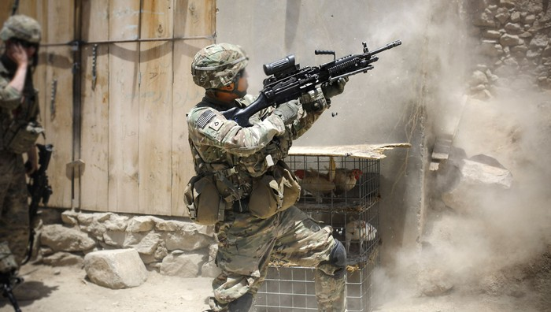

WASHINGTON—As they scoured the Internet for more juicy details about former CIA director David Petraeus’ affair with biographer Paula Broadwell, Americans were reportedly horrified today upon learning that a protracted, bloody war involving U.S. forces is currently raging in the nation of Afghanistan. “Oh my God, this is terrible,” Allie Lipscomb, 29, said after accidentally stumbling on an article about the war while she tried to ascertain details about what specific sexual acts Petraeus and Broadwell might have engaged in. “According to this, 2,000 American troops have died, 18,000 have been wounded, and more than 20,000 civilians have been killed. Jesus Christ. And it’s been happening for, like, 11 years.” Sources confirmed that after reading a few paragraphs about the brutal war, the nation quickly became distracted by a headline about Elmo puppeteer Kevin Clash’s alleged sexual abuse of a 16-year-old boy.

