AHMED RASHID |  | www.ahmedrashid.com
ARTICLES | Why we should worry about Balochistan
ARTICLES | BBC ONLINE, 01/20/2011
By Ahmed Rashid
It was a normal Sunday on 16 January in Pakistan's insurgency wracked province of Balochistan - five people were killed in targeted killings by unknown gunmen.
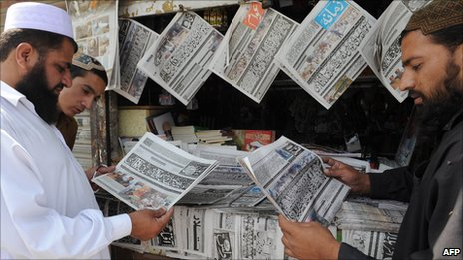
They included a lady health worker who was gunned down near the capital, Quetta; a taxi driver near the south-western town of Qila Saifullah shot dead in his cab; a teenage member of the Baloch Students' Organisation.
Also found was the body of Ghulam Hussain who had been kidnapped and was missing for the past eight months.
On the same day two tankers carrying fuel for Nato troops in Afghanistan were attacked near Quetta by the Taliban with rocket propelled grenades and torched.

Balochistan has become the "epicentre" of regional rivalries
The day before, 18 Nato tankers were burnt to cinders by gunmen operating further south.

Mayhem
As Pakistan slithers down the slope of Islamic extremism, economic meltdown and a continuing political crisis, there has been little concern for the long running insurgency in Balochistan that has picked up pace as Baloch separatists take advantage of the national chaos, while ever more ruthless retaliatory actions by the state go unchecked.
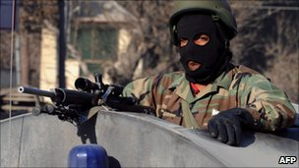
Every day dead bodies turn up, many of them innocent victims of the mayhem in the province.

According to human rights groups, the suspected killers either belong to the intelligence services or Baloch militant groups.

Nobody claims responsibility for the spiralling death toll.

The government launched a so-called peace process 15 months ago but it is stalled.

The region is heavily militarised

Of the 61 steps envisaged in the package, only 15 have been implemented so far, according to Dawn newspaper.
The government package was introduced to reduce the alienation and growing poverty of the Baloch people.

But the lack of action by the government and army has led to a stepped up hatred for the Pakistan state by Baloch youth, a terrible climate of fear because of the targeted killings and the collapse of the local economy and jobs as business flees the province.
No organ of the state has fulfilled its promises to the Baloch people over the past two years.
Parts of eastern Balochistan suffered massively from the devastating summer floods, but aid workers say help to the Baloch farmers has been far less than in other parts of the country.

No remedies
If the government has failed, so have the courts and the army.
A year ago the Supreme Court promised to look into the cases of hundreds of Baloch who have gone missing over the years or made to disappear, but no remedies have been offered.
"Missing" usually means they have been kidnapped and then killed or kept in secret locations.
Some of those missing are political figures, others victims of criminal syndicates looking for ransom, while others are just innocent bystanders.
The Baloch accuse the Inter Services Intelligence (ISI) of carrying out the kidnappings.
The ISI denies the charges and says government officials are being targeted by the Baloch.
The army has made little attempt to speed up political reconciliation.
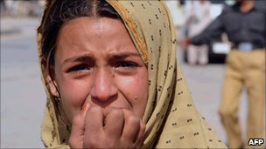

Blasts and ethnic violence have become a way of life in Balochistan province

As part of the government package, the army said it would not build any more cantonments in the province, nor extend its presence.
But it has handed over its powers to the much more loathed Frontier Corps (FC), which is officered by the army.
Baloch leaders say the FC is not accountable to the province's chief minister or governor and a new demand - to place it under civilian control - has come up.
The Human Rights Commission of Pakistan says the situation in the province is close to civil war.
In a recent report it says security has further deteriorated and 45 decomposed bodies have been found since July 2010 while 298 persons have gone missing.
There were 117 incidents of targeted killings last year, while another 119 people died in explosions and 19 in sectarian attacks.

'Wrecking havoc'
Last October, Amnesty International called on the government to investigate the torture and killings of more than 40 Baloch political activists and leaders in what it termed ''a kill and dump policy", as the dead were usually found with a bullet wound to the head and torture marks on their bodies.
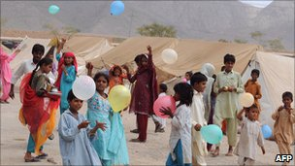
The military does not allow the International Committee of the Red Cross to monitor human rights abuses or take care of prisoners in the province.

The militants too have been wrecking havoc on non-Baloch who have been settled in the province for decades.

Human Rights Watch has documented the killings of nearly two dozen non-Baloch teachers and professors in the province over the past 12 months.

Last year's floods displaced many in Balochistan

Hundreds of teachers are fleeing the province bringing the already dire educational system to a standstill.
Balochistan has seen five insurgencies since 1947, but never before have militants targeted non-Baloch residents and civilians in this manner.
On 7 December, Balochistan Chief Minister Nawab Aslam Raisani survived a bomb blast on his motorcade that wounded nine people.
Nobody claimed responsibility but it is suspected that militants carried out the attack.

'Sanctuaries'
Balochistan has also become the epicentre for growing regional rivalries and warfare.
Leaders of the Afghan Taliban are based in Quetta, Chaman and Qila Saifullah - towns which border Afghanistan and are inhabited by Pashtun tribes.
The US and Nato command in Afghanistan say the Taliban use these sanctuaries to re-arm and rest their fighters, who then attack Nato forces in southern Afghanistan.

Gen David Petraeus, the Nato commander in Afghanistan, has threatened to bomb these sanctuaries if Pakistan does not deal with them.

Iran accuses Pakistan of allowing Jundullah, an anti-Iranian government terrorist group, to maintain bases in south-western Balochistan.
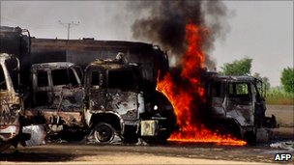

Fuel tanks en route to Nato forces in Afghanistan are often set on fire in the province

On 15 December, a suicide bomber killed 30 people at the Iranian port of Chabahar which borders Balochistan.
Jundullah claimed the bombing was a revenge for the execution of its leaders by Iran, some of whom had been handed over by Pakistan to Iran last year.
Pakistan says it has ousted all members of Jundullah from its soil.
Meanwhile, sectarian killings also have an international dimension.

Sunni extremist groups, some funded by supporters in the Arabian Gulf states, are actively killing Shias in Quetta, who largely belong to the Hazara ethnic group.
The Taliban are also involved in killing Hazaras, because they say they work for the Americans in Afghanistan.
Given the political chaos in the country it is unlikely that Balochistan will receive much attention in the months ahead.
But the collapse of law and order in the province could have serious repercussions on Pakistan's territorial integrity and heighten tensions between the largest province Punjab and the smaller provinces.

Source: http://www.bbc.co.uk/news/world-south-asia-12215145
Ahmed Rashid's book, Taliban, was updated and reissued recently on the 10th anniversary of its publication. His latest book is Descent into Chaos - The US and the Disaster in Pakistan, Afghanistan and Central Asia.

