AHMED RASHID |  | www.ahmedrashid.com
ARTICLES | Ahmed Rashid speaks at the Kentucky Author Forum. He was interviewed by Clarissa Ward, a foreign correspondent for CBS News.
ARTICLES | The Courier-Journal, 15/05/2012
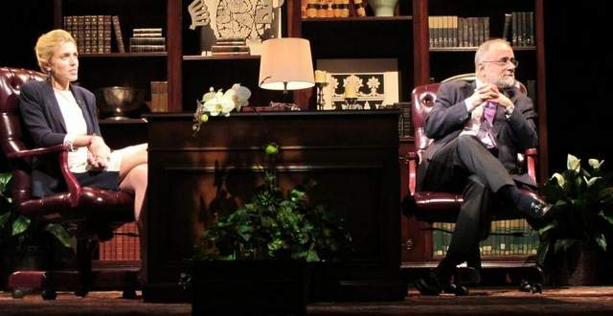

Written by Peter Smith

News & Local News

The marriage is a train wreck, steeped in suspicions of conspiracy and betrayal. It can be saved — but only if the detested in-law is allowed back into the house.
That was the stark summary by renowned Pakistani journalist Ahmed Rashid about the dysfunctional relationship between the United States and Pakistan — nuclear powers he said have to learn to live with each other.
Rashid, speaking Tuesday night at the Kentucky Author Forum, insisted that if the United States did what was once unthinkable — negotiate with the Taliban for a power-sharing arrangement in Afghanistan — that would be a crucial confidence-building measure to show Pakistan it takes its security concerns seriously.
“Certainly there is a future for the United States and Pakistan,” Rashid said in an interview with CBS News foreign correspondent Clarissa Ward at the Kentucky Center. The United States has “to find a way to bring Pakistan into this dialogue.”
Rashid spoke about his new book, “Pakistan on the Brink,” which follows up on his previous works on the Taliban and what he calls the blundering U.S. response in Afghanistan following the attacks on Sept. 11, 2001.
Rashid opened the forum with a bleak summary of modern Pakistan: its economy in shambles, its large young population seething, its power grid far overtaxed.
He said the Bush administration blundered by failing to take seriously the threat of a Taliban counter-insurgency after the Americans’ original rout of the Islamic government in 2001. He said much of that subsequent trouble can be summarized in one word — “Iraq.”
Pakistan, fearing a U.S. pullout from Afghanistan once the Americans turned attention to Iraq, backed the Taliban to help give it a proxy in Afghanistan as a counterweight to other nations’ proxies, he said.
He also faulted the U.S. for failing to use its window of good will in the region to build up the economies of Afghanistan and Pakistan. Now the security situation is so dire that American economic and agricultural advisors can’t work in the provinces of Afghanistan, he said.
He also faulted the Obama administration for failing to put enough priority on the relationship with Pakistan. He lamented the loss of the late U.S. envoy Richard Holbrooke, who he said understood the problem and tried to build consensus toward a regional solution to Afghanistan, involving all of its neighbors.
He said Afghan President Hamid Karzai has been in office too long but that his government — and future non-Taliban leaders — need to negotiate peace with the Taliban. The Afghan national army is incapable of fighting the Taliban the way the U.S. is, he said.
“It will improve its performance over time but it cannot be plunged into a war,” he said of the Afghan army. “It can be used to maintain a ceasefire.”
Rashid said a power-sharing arrangement with the central Afghan government would probably involve Taliban leadership in some southern provinces and representation in parliament and top government posts. But he said even the Taliban is pragmatic enough to foresee that if they retook power, the foreign aid the economy relies on would evaporate so quickly it would leave the populace starving, and blaming the Taliban .
Despite the bleak overall scenario, Rashid said he is optimistic and continues to reside in Pakistan. He said Pakistani youth are fed up with that nation’s military elite — which has frequently overturned elected governments.
The solution, he said, is “democracy and more democracy.”
Afterward, some local Pakistani-Americans said that if anything, Rashid was too optimistic.
Dr. Muhammad Babar, a local physician, said economic desperation in Pakistan is fueling religious fundamentalism and that the nation’s economy needs rebuilding.
“It’s social, not religious,” agreed fellow physician Raja Kaikaus.

Reporter Peter Smith can be reached at (502) 582-4469.

